Experiment-10

Triggers

1.create a table with attribute sname and another table with newname



2.create a trigger to insert second table before inserting the first table

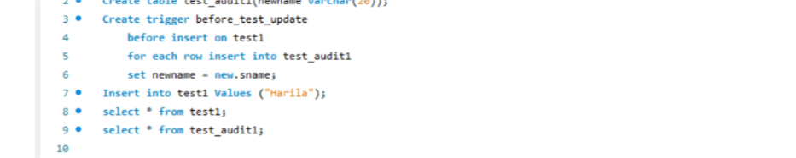

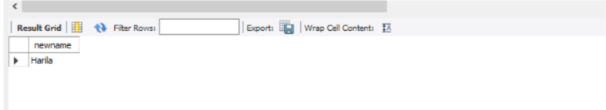

* Create a table for account details with attributes account number and an amount

